TASK 3

Description:

The topics we covered in this program is:

Control Structure,

If selection statement,

switch Multiple selection statement,

while iteration Statement,

Counter Control iteration,

This program is simple temperature converter.

There is choice option for each conversion, if you want conversion Celsius to Fahrenheit the enter 1 and so on.

Enter 0 to Quit or ending the program

Enter 1. Farhenheit To Celsius

Enter 2. Celsuis To Frahenheit

Enter 3. Celsuis To Kelvin

Enter 4. Kelvin To Celsuis

If user Enter 0, it will quit program.

If user Enter 1, it will ask for Fahrenheit temperature and print temperature in Celsius.

If user Enter 2, it will ask for Celsius temperature and print temperature in farhenheit

If user Enter 3, it will ask for celsius temperature and print temperature in kelvin.

If user Enter 4, it will ask for kelvin temperature and print temperature in Celsius

**Code**:

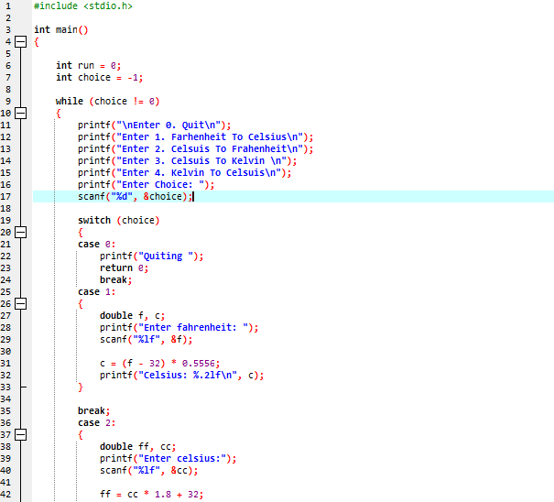

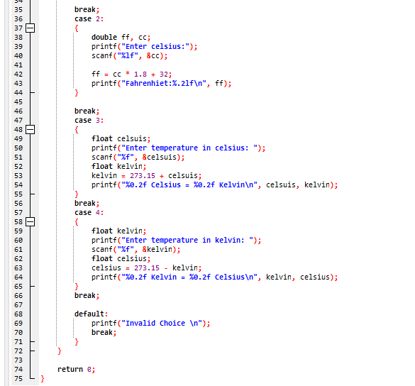

Output:

